
Department of Computer Science and Engineering
ALGORITHMIC PROBLEM-SOLVING HACKATHON (APSH 2026)
PROJECT DOCUMENTATION
Date: 03-10-2026 | Venue: 3rd Floor, A & B Blocks
Field | Details
Project Title | Local Marketplace Platform (Problem No. 56): A MERN-Based Marketplace for Local Sellers
Team Name / Team No. | 1
Year / Semester / Section | II Year B.Tech / ___ Sem / ___
Algorithm Paradigm Used | Layered (3-tier) REST architecture with MVC; indexed search (B-tree), JWT and bcrypt for security
Programming Language / Tools | JavaScript; MongoDB, Express.js, React.js, Node.js (MERN), Mongoose, JWT, bcrypt, Postman, Git
Faculty Mentor
Team Members
S.No | Name of the Student | Roll No. | Role
1 | Matam Akshitha | 25MVCSMR0417 | Team Lead
2 | T.Eunice Divya | 25MVCSMR0446
3 | Saigari Tejashwini | 25MVCSMR0435
4 | Eareti Vasantha | 25MVCSMR0391

1. Problem Statement
Local shopkeepers, home-based sellers and small producers rarely have an affordable online presence, so nearby customers cannot easily find out what is available, at what price and in what quantity. The aim of this project is to build a MERN-based Local Marketplace Platform on which local sellers list their products and customers in the same locality can search, view and compare them.
The system manages seller, product, price, quantity and location data in MongoDB. React provides the user interface, while Node.js and Express.js expose the backend REST APIs. The platform supports adding, viewing, updating and managing records, with authentication and role-based access control (Customer, Seller and Admin).
Inputs
- Account data: name, email, password, phone, role and (for sellers) shop name and location.
- Product data: name, description, category, price, quantity, location (city, area, coordinates) and image URL.
- Search criteria: keyword, category, location, price range and page number.
Outputs
- Paginated product listings showing price, available quantity, seller and location, and a product detail view.
- A seller dashboard to add, edit and delete own products, and an admin panel to manage users and listings.
- Success and error responses (JSON) with proper HTTP status codes, shown to the user as clear messages.
Constraints
- Price must be a non-negative number and quantity a non-negative integer; required fields cannot be empty.
- Only authenticated sellers can create listings, and a seller can modify or delete only their own products.
- Passwords must never be stored in plain text; protected APIs must reject missing, invalid or expired tokens.
- Listing and search responses must be paginated so that response size and time stay bounded as data grows.
2. Objectives
- Demonstrate MERN stack development by building a complete working application in which React, Express.js, Node.js and MongoDB communicate through JSON over REST.
- Implement CRUD operations in MongoDB for sellers, products, price, quantity and location, with validation and indexes for fast search.
- Build secure REST APIs using Node.js and Express.js, with JWT authentication and role-based access control for Customer, Seller and Admin.
- Develop a responsive React frontend that displays listings, search results and dashboards clearly, and reports project results and errors to the user.
3. Proposed Approach
Design approach. Instead of a single algorithmic paradigm, this project follows a layered (three-tier) client-server architecture with a RESTful API and the MVC pattern on the server. The React client (presentation tier) talks to an Express application tier through stateless JSON APIs, and Mongoose maps application objects to MongoDB (data tier). Authentication is stateless JWT-based, and authorisation is enforced by a role-checking middleware placed in front of protected routes.
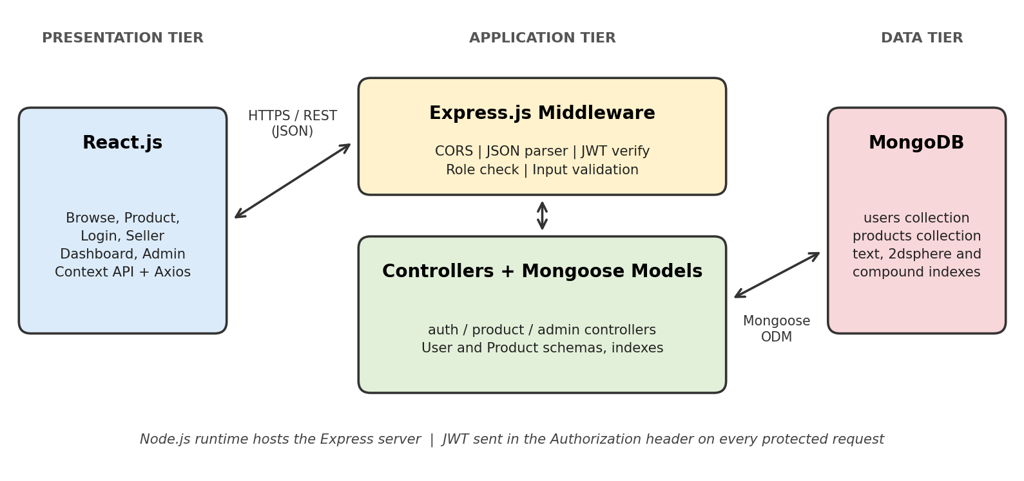
Fig. 1: System architecture of the Local Marketplace Platform
Why this approach suits the problem.
- One language (JavaScript) is used end to end, and data moves as JSON with no conversion between layers.
- MongoDB documents suit products whose attributes differ by category, and MongoDB offers text and geospatial (2dsphere) indexes that support keyword and "near me" search.
- Stateless JWT authentication keeps the API simple to scale because no server-side session storage is needed.
- Separating routes, controllers, models and middleware keeps the code testable and easy to extend.
Alternatives considered.
- MEAN (Angular): equally valid, but Angular has a steeper learning curve than React for a short project.
- Django or Spring with a SQL database: strong relational integrity, but it needs a second language and rigid schemas for varied product data.
- Firebase (BaaS): quick to start, but it hides the backend, which defeats the objective of building REST APIs with Express.
- Session-based authentication: simple, but it requires server-side state and is harder to scale than JWT.
4. Algorithm / Pseudocode
The core algorithms are given below in pseudocode. Each protected operation first runs through the authentication and authorisation middleware.
A. Register and Login
REGISTER(name, email, password, role):
IF any field is empty or email format is invalid: RETURN 400
IF a user with this email exists: RETURN 409
IF role is not in {CUSTOMER, SELLER}: role <- CUSTOMER // ADMIN is never self-assigned
hash <- bcrypt(password, saltRounds)
SAVE user(name, email, hash, role)
RETURN 201

LOGIN(email, password):
user <- FIND user BY email
IF user is null OR NOT bcrypt.compare(password, user.hash): RETURN 401
token <- JWT.sign({id, role}, SECRET, expiresIn)
RETURN 200, token, user profile
B. Authentication and Role Middleware
AUTHENTICATE(request):
token <- request.headers.authorization (Bearer scheme)
IF token is missing: RETURN 401
payload <- JWT.verify(token, SECRET) // fails if invalid or expired
request.user <- payload; CONTINUE

AUTHORIZE(allowedRoles)(request):
IF request.user.role NOT IN allowedRoles: RETURN 403
CONTINUE
C. Add Product (Seller)
ADD_PRODUCT(request): // AUTHENTICATE, AUTHORIZE(SELLER)
data <- request.body
IF data.price < 0 OR data.quantity < 0 OR quantity is not an integer: RETURN 400
product <- NEW Product(data, seller = request.user.id)
SAVE product
RETURN 201, product
D. Search Products (Filter, Sort and Paginate)
SEARCH(q, category, city, minP, maxP, page, limit):
filter <- {}
IF q: filter.$text <- q
IF category: filter.category <- category
IF city: filter.location.city <- city
IF minP OR maxP: filter.price <- {$gte: minP, $lte: maxP}
skip <- (page - 1) * limit
items <- Product.find(filter).sort(createdAt DESC).skip(skip).limit(limit)
total <- Product.countDocuments(filter)
RETURN items, total, page
E. Update and Delete with Ownership Check
UPDATE_OR_DELETE(id, changes): // AUTHENTICATE, AUTHORIZE(SELLER, ADMIN)
product <- Product.findById(id)
IF product is null: RETURN 404
IF user.role != ADMIN AND product.seller != user.id: RETURN 403
IF operation is UPDATE: apply changes (re-validate price, quantity); SAVE
ELSE: REMOVE product
RETURN 200
5. Complexity Analysis
The complexity below is for the most frequently used operation, product search with filters and pagination. Here n is the number of products in the collection and k is the page size (the number of documents returned).
Complexity | Best Case | Average Case | Worst Case
Time | O(log n + k) | O(log n + k) | O(n), full scan
Space | O(k) | O(k) | O(n), if not paginated
Justification. With a compound index on the filtered fields, MongoDB walks a B-tree (O(log n)) to the first matching entry and then reads at most k documents. Without a usable index (for example an unanchored regex search), MongoDB performs a collection scan, which is O(n) in the worst case. Pagination keeps the working set per request at O(k) instead of O(n).
Other operations. Fetching, updating or deleting a product by its _id takes O(log n) through the default _id index. Inserting a document costs O(log n) per maintained index. Password hashing with bcrypt has a deliberately tuned constant cost per login, and JWT verification is O(1) in the number of users.
6. Implementation
Backend modules (Node.js and Express.js)
- models/ Mongoose schemas for User and Product, including validation rules and indexes.
- controllers/ business logic for authentication, products and admin operations.
- routes/ REST route definitions that map URLs to controllers.
- middleware/ JWT authentication, role authorisation, input validation and a central error handler.
- config/ database connection and environment variables (.env) such as MONGO_URI and JWT_SECRET.
Frontend modules (React.js)
- Pages: Home/Browse, Product Details, Login, Register, Seller Dashboard (add, edit, delete) and Admin Panel.
- Components: ProductCard, SearchBar and Filters, Pagination, ProductForm, Navbar and ProtectedRoute.
- State and API: React Router for navigation, Context API for the logged-in user and token, and an Axios instance that attaches the JWT to every request.
Data structures and database design
Data is stored as JSON-like documents in two collections. The seller profile is stored inside the User document (role = SELLER), and each product holds a reference to its seller.
Collection | Field | Type and notes
User | name, email | String; email is unique and required
 | passwordHash | String; bcrypt hash, excluded from API responses
 | role | Enum: customer, seller, admin (default customer)
 | phone, shopName, location | Seller contact and shop details
Product | name, description, category | String; name and category required; text index on name and description
 | price | Number, min 0
 | quantity | Number (integer), min 0
 | location | Object: city, area and GeoJSON Point (2dsphere index)
 | imageUrl | String (optional)
 | seller | ObjectId reference to User; indexed
 | createdAt, updatedAt | Date; maintained automatically by Mongoose timestamps

REST API endpoints
Method | Endpoint | Access | Description
POST | /api/auth/register | Public | Create a customer or seller account
POST | /api/auth/login | Public | Authenticate and receive a JWT
GET | /api/products | Public | Search, filter and paginate products
GET | /api/products/:id | Public | View one product
GET | /api/products/mine | Seller | List the logged-in seller's products
POST | /api/products | Seller | Add a new product
PUT | /api/products/:id | Owner, Admin | Update price, quantity or details
DELETE | /api/products/:id | Owner, Admin | Remove a product
GET | /api/admin/users | Admin | List and manage users
PATCH | /api/admin/users/:id | Admin | Activate, deactivate or change a user

Tools and platform
MongoDB (Atlas or local), Express.js, React.js (Vite), Node.js, Mongoose, jsonwebtoken, bcryptjs, express-validator, cors, dotenv, Axios, React Router, Postman for API testing, Git/GitHub for version control and Visual Studio Code as the editor.
7. Results and Test Cases
The following test cases verify the main operations. The expected output is what the implementation must produce; mark each as Pass or Fail while testing.
ID | Scenario | Sample Input | Expected Output | Status
T1 | Register a seller | name, email, password, role = seller | 201 Created; account saved with hashed password | Pass/fail
T2 | Duplicate email | Register again with the same email | 409 Conflict with message | Pass/fail
T3 | Login with valid credentials | Correct email and password | 200 OK with JWT and user profile | Pass/fail
T4 | Login with wrong password | Correct email, wrong password | 401 Unauthorized | Pass/fail
T5 | Add product as seller | Name = "Fresh Mangoes", price = 120, quantity = 40, city = "Hyderabad" | 201 Created; product appears in the seller dashboard | Pass/fail
T6 | Add product as customer | Same payload using a customer token | 403 Forbidden | Pass/fail
T7 | Invalid price or quantity | price = -5 or quantity = 2.5 | 400 Bad Request with validation message | Pass/fail
T8 | Search with filters | q = mango, city = Hyderabad, price 50 to 200, page 1 | Only matching products, at most one page, with total count | Pass/fail
T9 | Update another seller's product | PUT with a different seller's token | 403 Forbidden; data unchanged | Pass/fail
T10 | Update own product quantity | quantity = 25 | 200 OK; the new quantity is shown in listings | Pass/fail
T11 | Delete product as admin | DELETE using an admin token | 200 OK; product no longer listed | Pass/fail
T12 | Access API without a token | GET /api/products/mine with no header | 401 Unauthorized | Pass/fail

Screenshots
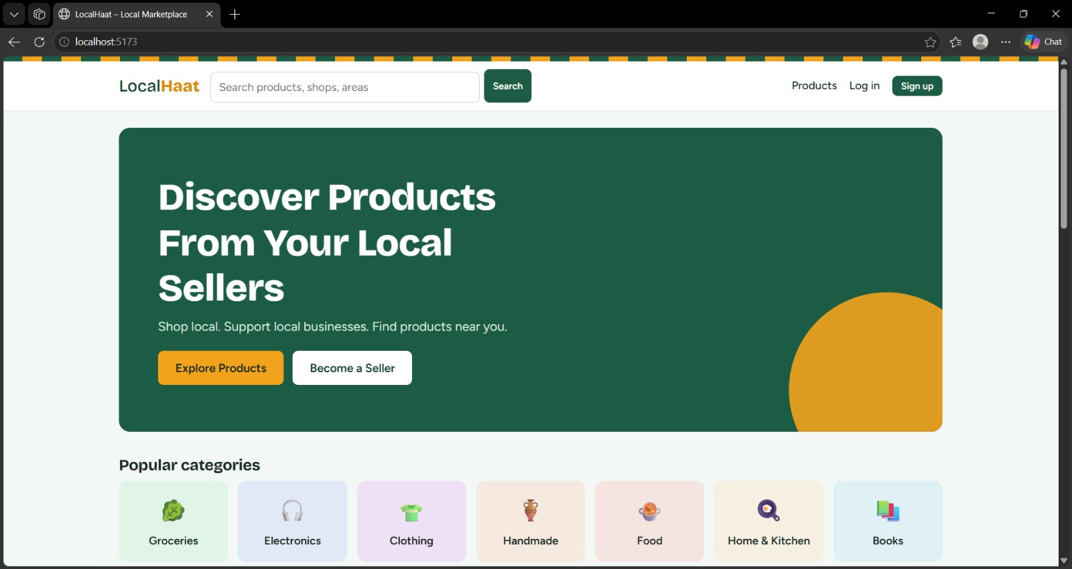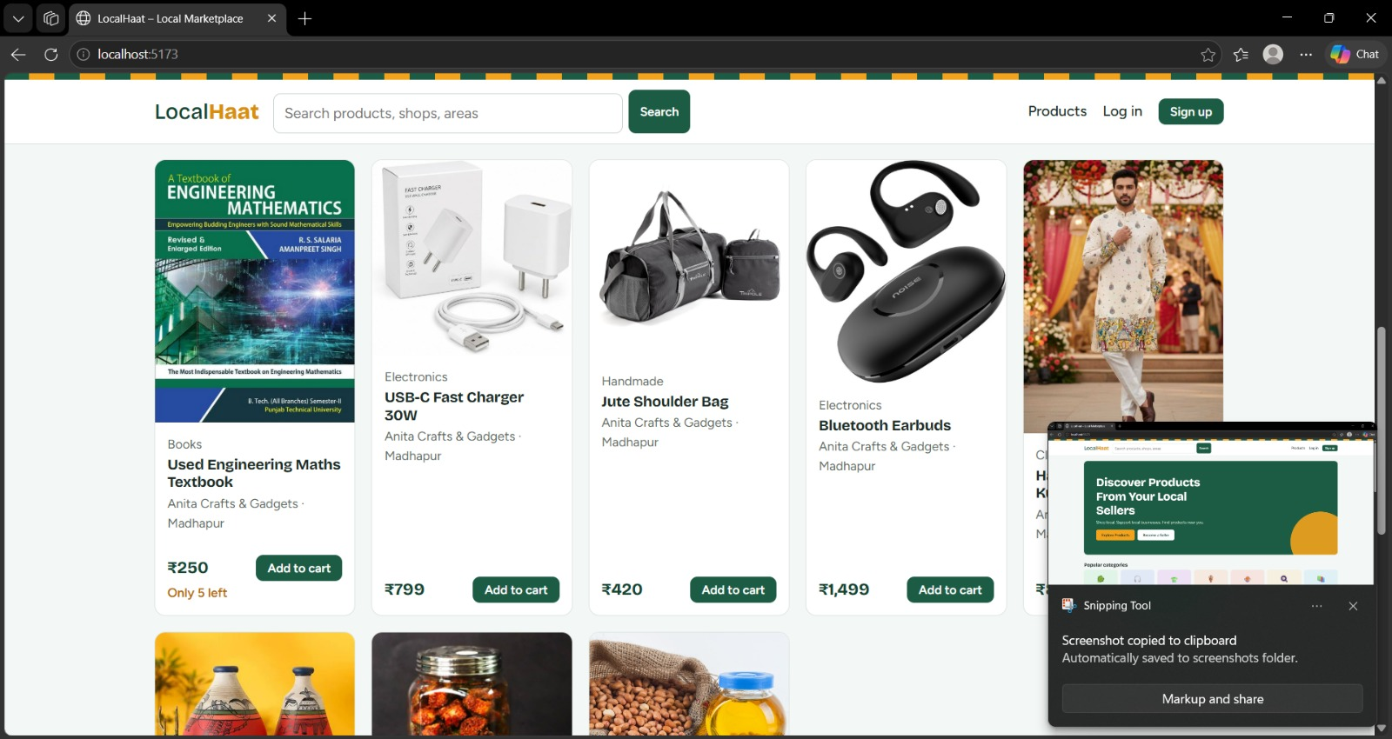
Performance comparison with a naive approach
The naive approach filters the products in application code or runs a query with no index, which forces MongoDB to scan the whole collection (COLLSCAN). The proposed approach uses compound, text and geospatial indexes (IXSCAN) together with pagination. To compare them, seed the database with sample data, run the same search with db.products.find(filter).explain("executionStats") and record the values below.
Number of products | Without index (COLLSCAN) | With index (IXSCAN)
1,000
10,000
100,000

Record the execution time (executionTimeMillis) and the documents examined (totalDocsExamined) in each cell. Documents examined is expected to grow with n without an index, but to stay close to k with one.
8. Conclusion and Future Scope
Conclusion. The Local Marketplace Platform demonstrates a complete MERN application. Sellers can list and manage products with price, quantity and location. Customers can search and view nearby listings, and administrators can supervise users and content. The project covers CRUD operations in MongoDB, REST APIs in Node.js and Express.js, a React user interface, and JWT-based authentication with role-based access. Indexing and pagination keep the search operation efficient as the data grows.
Future scope.
- Shopping cart, order management and online payment integration (for example UPI or Razorpay).
- "Near me" search with distance sorting using MongoDB geospatial queries and browser geolocation.
- Product image upload to cloud storage, plus ratings and reviews for sellers.
- Real-time stock updates and notifications using WebSockets, and a mobile app with React Native.
- Automated testing (Jest, Supertest), Docker-based deployment and CI/CD.
9. References
[1] MongoDB, Inc., "MongoDB Manual," MongoDB Documentation. [Online]. Available: https://www.mongodb.com/docs/manual/
[2] OpenJS Foundation, "Express - Node.js web application framework." [Online]. Available: https://expressjs.com/
[3] Meta Platforms, Inc., "React Documentation." [Online]. Available: https://react.dev/
[4] OpenJS Foundation, "Node.js Documentation." [Online]. Available: https://nodejs.org/en/docs
[5] Mongoose, "Mongoose ODM Documentation." [Online]. Available: https://mongoosejs.com/docs/
[6] M. Jones, J. Bradley and N. Sakimura, "JSON Web Token (JWT)," RFC 7519, IETF, May 2015.
[7] N. Provos and D. Mazieres, "A future-adaptable password scheme," in Proc. USENIX Annual Technical Conf., FREENIX Track, Monterey, CA, USA, 1999, pp. 81-91.
[8] R. T. Fielding, "Architectural styles and the design of network-based software architectures," Ph.D. dissertation, Dept. Inf. Comput. Sci., Univ. California, Irvine, CA, USA, 2000.

